**ASSIGNMENT 2 FRONT SHEET**

|  |  |  |  |
| --- | --- | --- | --- |
| **Qualification** | **BTEC Level 5 HND Diploma in Computing** | | |
| **Unit number and title** | 10: Website Design & Development | | |
| **Submission date** | 14/5/2002 | **Date Received 1st submission** |  |
| **Re-submission Date** |  | **Date Received 2nd submission** |  |
| **Student Name** | Tran Lam Dat | **Student ID** | GBC200045 |
| **Class** | GCC0902 | **Assessor name** | Nguyen Hung Dung |
| **Student declaration**  I certify that the assignment submission is entirely my own work and I fully understand the consequences of plagiarism. I understand that making a false declaration is a form of malpractice. | | | |
|  |  | **Student’s signature** |  |

**Grading grid**

|  |  |  |  |  |  |  |
| --- | --- | --- | --- | --- | --- | --- |
| P5 | P6 | P7 | M4 | M5 | D2 | D3 |
|  |  |  |  |  |  |  |

|  |  |  |
| --- | --- | --- |
| **❒ Summative Feedback: ❒ Resubmission Feedback:** | | |
| **Grade:** | **Assessor Signature:** | **Date:** |
| **Signature & Date:** | | |

Assignment Brief 2 (RQF)

Higher National Certificate/Diploma in Computing

|  |  |
| --- | --- |
| **Student Name/ID Number:** |  |
| **Unit Number and Title:** | **Unit 10: Website Design & Development** |
| **Academic Year:** | **2021 – 2022** |
| **Unit Assessor:** | **Hoang Nhu Vinh** |
| **Assignment Title:** | **Website Design and Implementation** |
| **Issue Date:** | **01 April 2021** |
| **Submission Date:** |  |
| **Internal Verifier Name:** |  |
| **Date:** |  |

|  |
| --- |
| **Submission Format:** |
| *Format:*   1. A report document including below sections    * Section 1: A review of appreciate web design principles, standards and guidelines.    * Section 2: Design document for online shopping website.    * Section 3: Implementation of website design.    * Section 4: Test plan and test evaluation. 2. A compressed file that encapsulates all source code and particular necessary resources including files of images, style sheets, java script and other files to support to install multipage website such as sql script and installation guide.   *Submission*   * Students are compulsory to submit the assignment in due date and in a way requested by the Tutor. * The form of submission will be a soft copy posted on [http://cms.greenwich.edu.vn/.](http://cms.greenwich.edu.vn/) * Remember to convert the word file into PDF file before the submission on CMS.   *Note:*   * The individual Assignment *must* be your own work, and not copied by or from another student. * If you use ideas, quotes or data (such as diagrams) from books, journals or other sources, you must reference your sources, using the Harvard style. * Make sure that you understand and follow the guidelines to avoid plagiarism. Failure to comply this requirement will result in a failed assignment. |

|  |
| --- |
| **Unit Learning Outcomes:** |
| **LO3** Utilize website technologies, tools and techniques with good design principles to create a multipage website.  **LO4** Create and use a Test Plan to review the performance and design of a multipage website. |
| **Assignment Brief and Guidance:** |
| **Assignment scenario**  You currently work for a software training company that produces courses and topic presentations to established companies and, importantly, to new start-ups. MWS wishes to pursue a bespoke web-based e-commerce solution. MWS were impressed with your presentations and wishes to continue with the design and development of an e-commerce website.  A sister company develops web solutions and you have been tasked with taking the lead on the MWS solution you outlined previously.  You are now required to design and create an interactive website with the emphasis being on the production of a set of simple dynamic web pages, which embody good design principles. The site will be themed around a template which would be most appropriate to MWS, with placeholders for text and content. Images and icons will be used, to give MWS a feel for the proposed website design. You will also include a membership area, where users can register to have access to restricted areas.  You will base on *MWS-CaseStudy.docx* for more information. |

|  |  |  |  |
| --- | --- | --- | --- |
| **Learning Outcomes and Assessment Criteria (Assignment 2):** | | | |
| Learning Outcome | Pass | Merit | Distinction |
| LO3 | **P5** Create a design document for a branded, multipage website supported with medium fidelity wireframes and a full set of client and user requirements. | **M4** Compare and contrast the multipage website created to the design document. | **D2** Critically evaluate the design and development process against your design document and analyse any technical challenges. |
|  | **P6** Use your design document with appropriate principles, standards and guidelines to produce a branded, multipage website supported with realistic content. |  |  |
| LO4 | **P7** Create a suitable Test Plan identifying key performance area and use it to review the functionality and performance of your website. User Experience (UX) and User Interface (UI). | **M5** Evaluate the Quality Assurance (QA) process and review how it was implemented during your design and development stages. | D3 Critically evaluate the results of your Test Plan and include a review of the overall success of your multipage website; use this evaluation to explain any areas of success and provide justified recommendations for areas that require improvement. |
|  |  |  |  |

**Assignment 2**

1. Chapter 1: Introduction
2. Good web design principles

Alignment:

Alignment is all about the positioning of your elements, including text and imagery, as well as buttons, and content boxes. To align something in web design means to position the elements within a straight line, or in the correct positioning. For some web design schemes, alignment is purposefully broken, to create an asymmetrical design. However, the elements themselves will instead be aligned in some way. This will ensure:

There is equal space around and between content

Content appears in spaces where this is expected by website users

Each text paragraph is aligned together, even if this is different to the rest of the page (pumpkinwebdesign, 2021).

Whitespace:

Whitespace, many times referred to as negative space, is the portion of a page left unmarked, the portion that is left blank, or (as Mark would quote) the empty space in a page. In web design terms, it’s the space between graphics, columns, images, text, margins and other elements. It is the space left untouched in order to smooth things out and transform a page into something elegant. It is also the blank space that reminds us that simpler designs are beautiful and that we don’t need to create a layout filled with text and graphical elements to deliver a clear and direct message.

Even though we call it white space, it doesn’t mean the actual space must be white. The blank space may be filled with any color as long as it is free of any elements like text or images. Whitespace is also associated with elegance and sophistication since it is a way to organize text, organize elements and guide users attention to certain elements.

An example of great usage of whitespace that we are all familiar with is [Google](http://www.google.com/). Their homepage is filled with whitespace so we can focus on what is important: search (Muller, 2012).

1. Chapter 2: Design document (P5)

## Client and user requirement analysis

* 1. Project Specification

Mid-Autumn-Cakes.com is an online store with a wide variety of Cakes. Now they want to revamp their website with all the products listed on the site. Consumers will easily view different products and decide to buy the right product that meets their requirements.

A website needs to be designed to display the different types of cakes available in the store. Venue details, feedback must be included.

The website will be developed for the Windows Platform using HTML, CSS, JavaScript, PHP and Bootstrap. The website will work fine on all leading browsers including Chrome, IE, Firefox, etc.

* 1. Client: Mid-Autumn-Cakes Store
  2. Input provide by the Client

- Input to the system

o Information about bag category: category id, category name, Description.

o Information about Cakes: id, name, category, price, short description, quantity, image of product.

o Information of customer: Username, password, confirm password, fullname, email, address, telephone, gender, date of birth.

- Output from the system

o List cake Category.

o List all cakes and cakes detail.

- Process involved in the system

o Processing customer’s registration.

o Processing customer’s login.

o Adding, updating, deleting category.

o Adding, updating, deleting prodict.

* 1. Scope of the Work

- Design a website for online shopping with multi pages with <Mid-Autumn-Cakes>).

- Customers register members of the site and log in to buy products.

- For administrators, perform the following functions:

+ Add, edit and delete customer information

+ Add, edit and delete products.

+ Add, edit and delete product categories

* 1. Customer Acceptance Criteria

|  |  |
| --- | --- |
| **No** | **Customer’s Acceptance Criteria** |
|  | The Home Page should be created making use of Sections with a suitable logo, the header section can be added which will show images of various Cakes. |
|  | The website must contain a navigation link to the database in order to add, update and delete cakes for the site. |
|  | Specification and Pricing of Cakes should be added along with the images. |
|  | Customer can register member of store and then can login the website |
|  | Only the administrator can manage customer information and product information in the store. |
|  | Administrators can perform the following functions: Add, edit and delete customer. |
|  | Administrators can perform the following functions: Add, edit and delete product categories. |

## Architecture of the Application

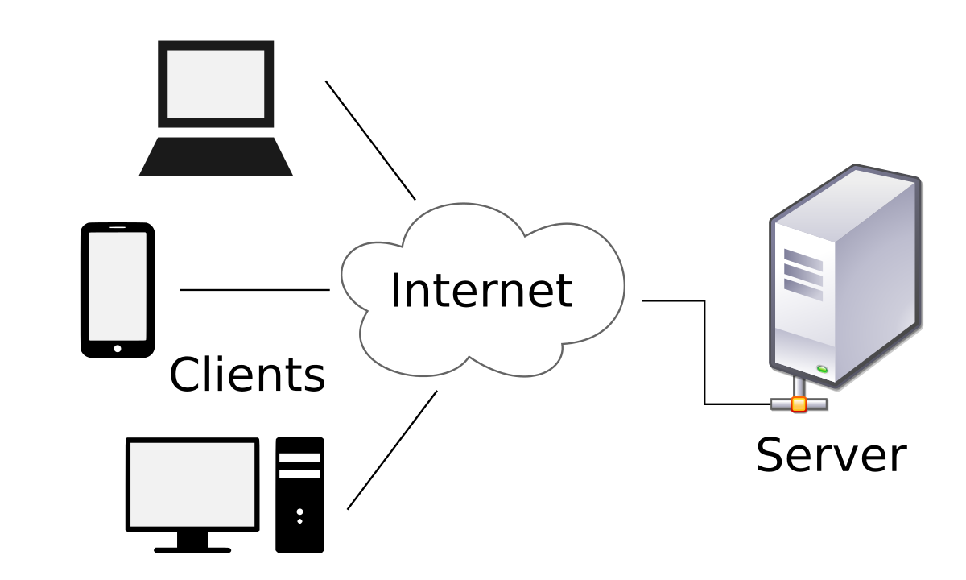

## Data Flow Diagram

Mid-Autumn-Cakes.com

Administrator

Customer

## Use case diagram

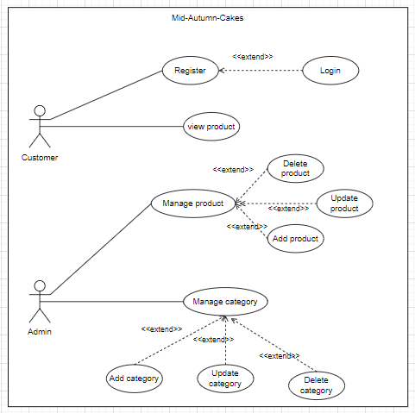

## Database diagram

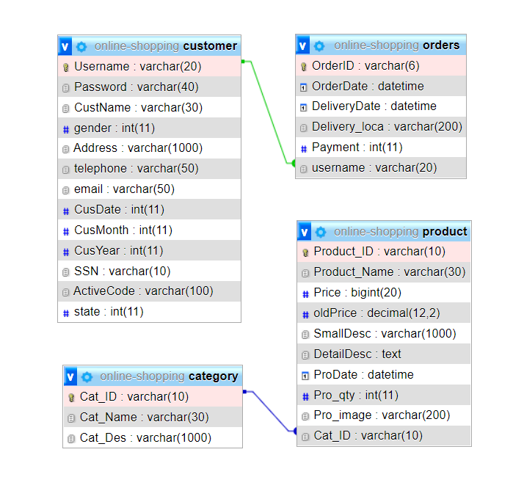

## Site map

* Before logging in

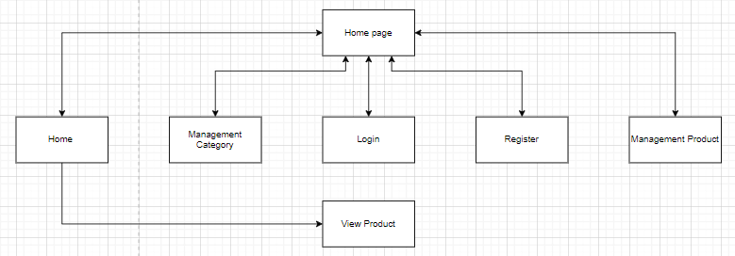

* After customer login

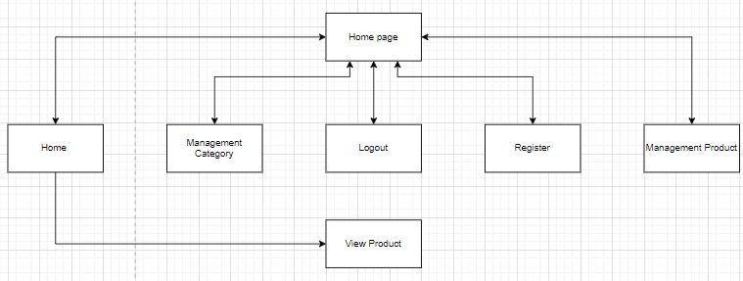

* After the manager login

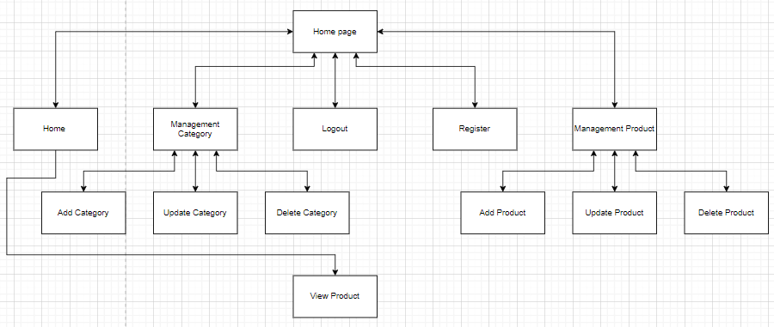

## Wire frames and specific explanation

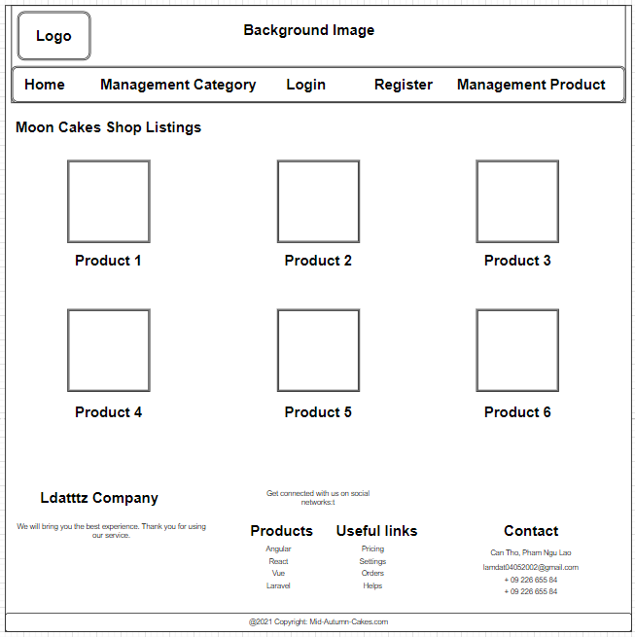

1. Chapter 3: Website implementation Functional screen shot after implementation (P6)

**The function of website.**

On the front page It will not allow you to access its function pages such as category management or product management if it is a regular user account or if you are not logged in. Other features, such as login and registration, are also available on the homepage. Contact information, such as a phone number and an address, is available on the website.

The website's user interface is as follows:

This is header and body of website:

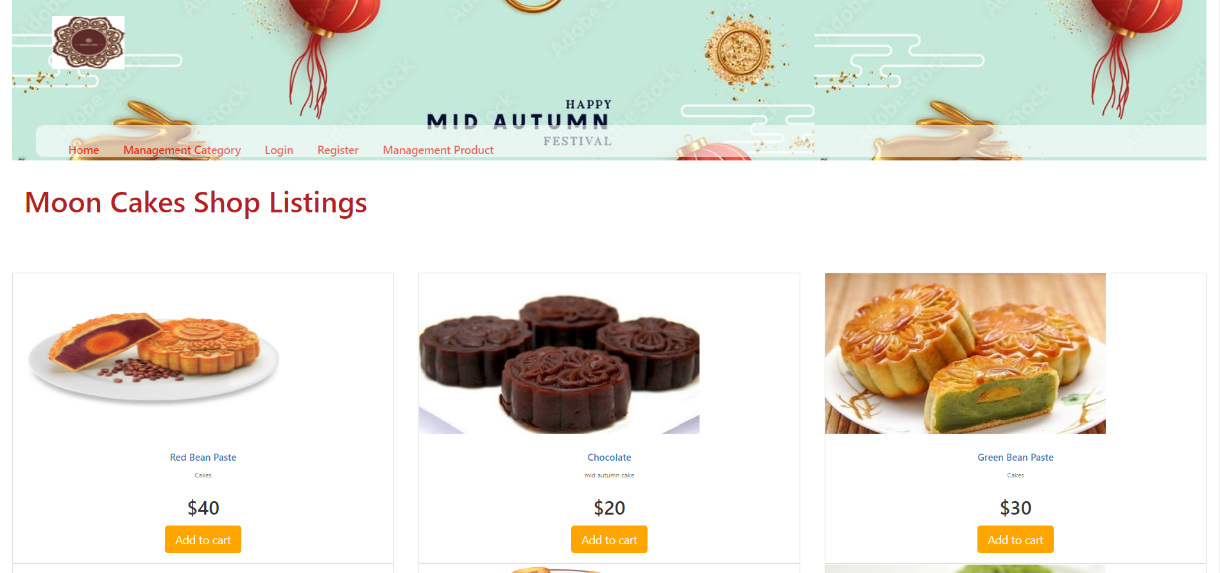

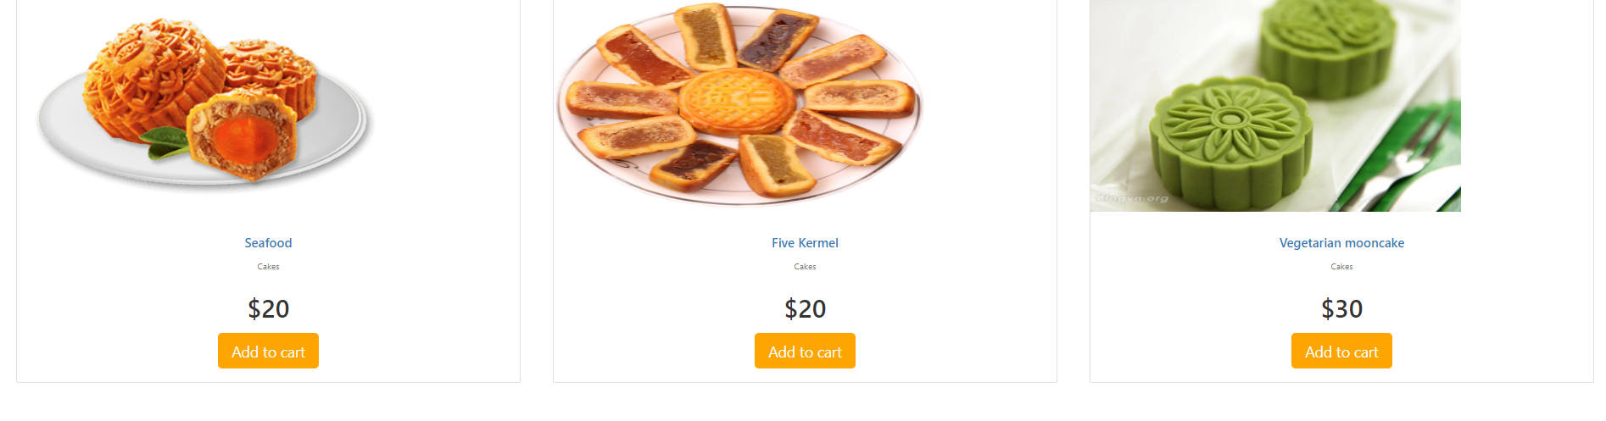

This is footer of the website:



**The function of the website.**

* **Register:**

First, this is a page for customers to register their personal information.

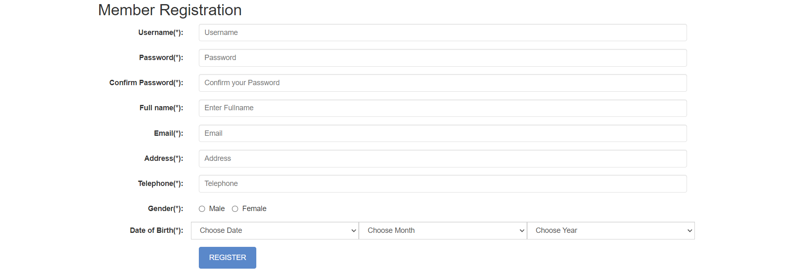

Users must complete all fields in the textbox to register as a member, including Username, password, confirmation password, full name, email, address, phone, gender, and date of birth. Then, to establish an account, left-click the Register button.

In the blank field, the user must fill in all of his personal information.

The user must input and confirm the same password.

A password of at least 5 characters is required.

The year of birth must be entered.

The website will display the message "You have registered successfully " if the registration is successful.

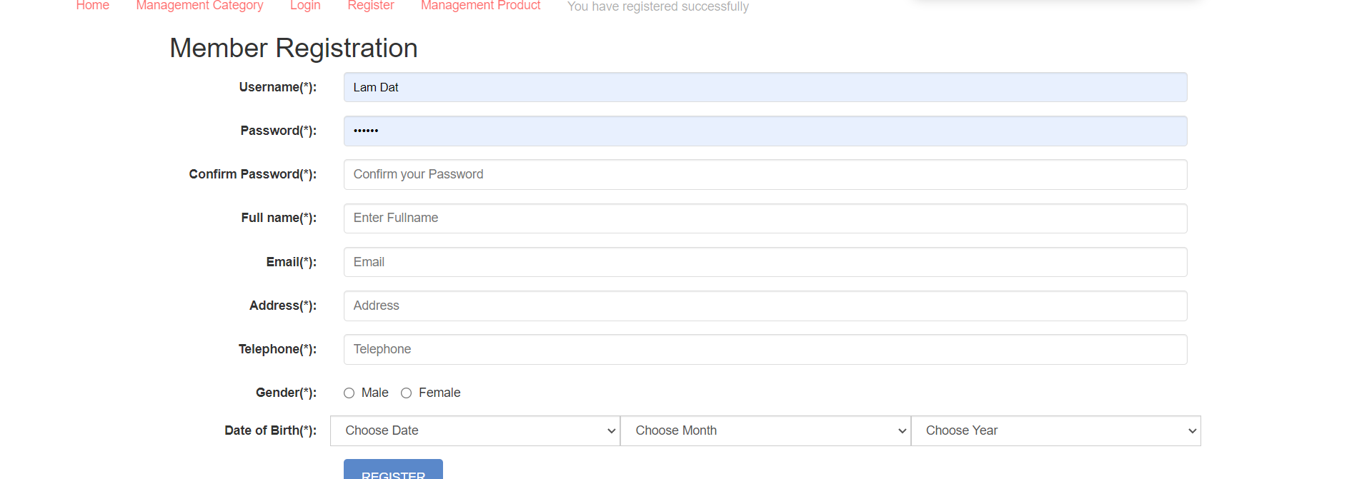

Error notices come when users fail to fill in information or supply insufficient information.

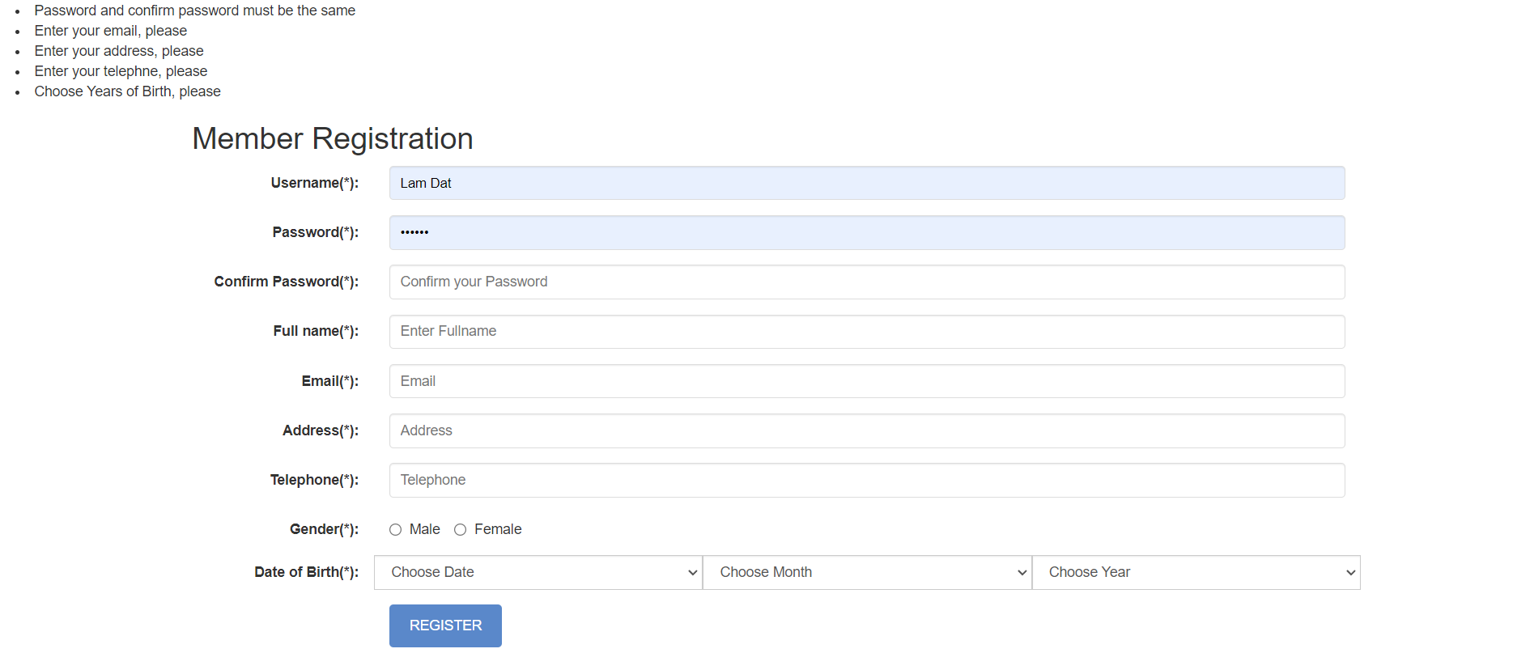

* **Login:**

When the consumer clicks on the login button, the interface displays the following form, which the customer has to fill in to make a purchase from the store.

Once linked to their customer subscription account, customers can view changes to their profile and store product catalogs.

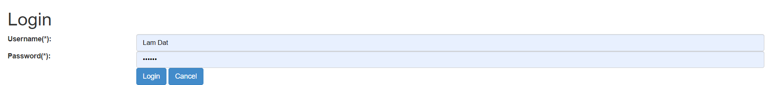

Error notices come when users fail to fill in information or supply insufficient information.

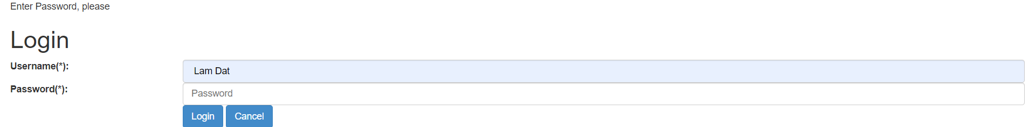

If you do not enter the correct registered account, the login will fail.

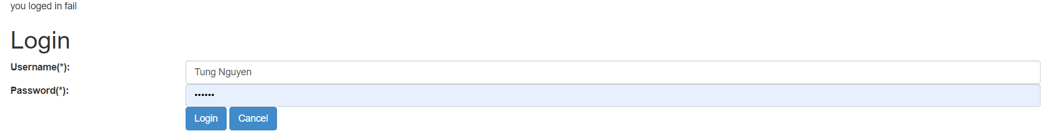

When the customer successfully login, the system will redirect the user to the home page, the login and register button at the top will be replaced with "Hi (username)" and log out. Here, customers can see the products and the price of each product to choose from.

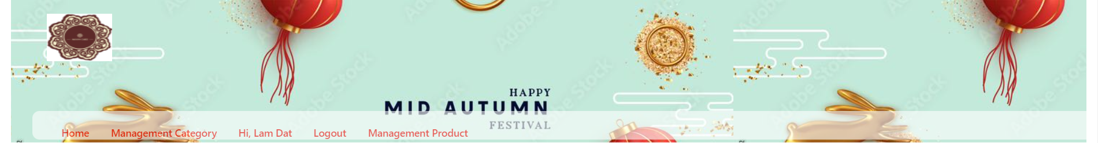

* **Update Profile**

Here, users can change their personal information such as password, confirm password, full name, address and phone number. Username and email will be preserved.

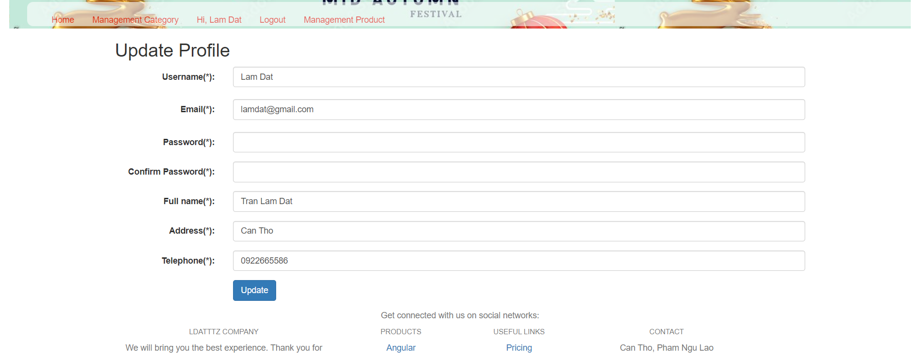

* **Category Management:**

This is a function that only administrators can access. If you are a user, an error message will appear.

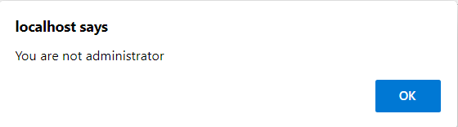

* Add category

To add category information, the administrator must click on the Add icon:

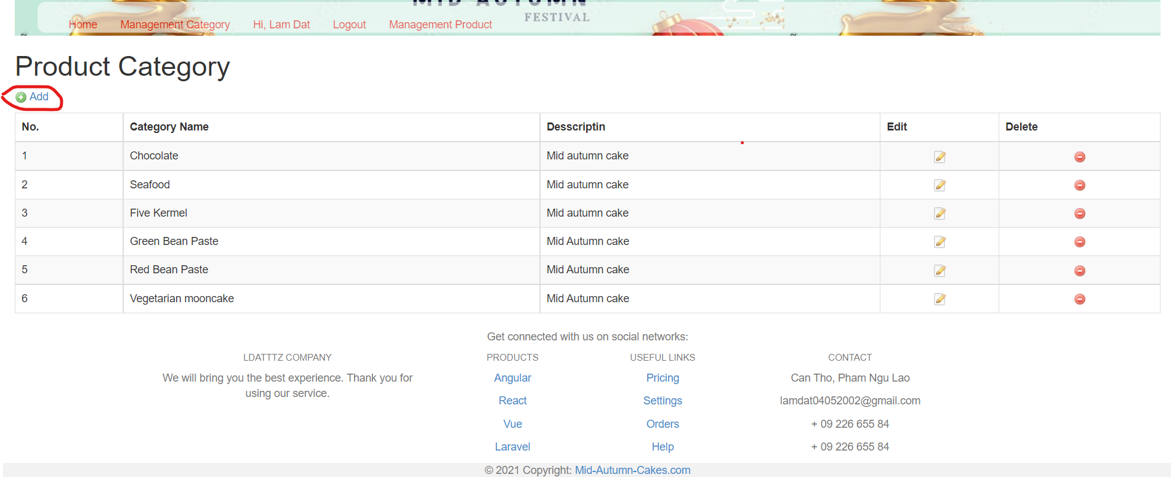

The following interface will be displayed.

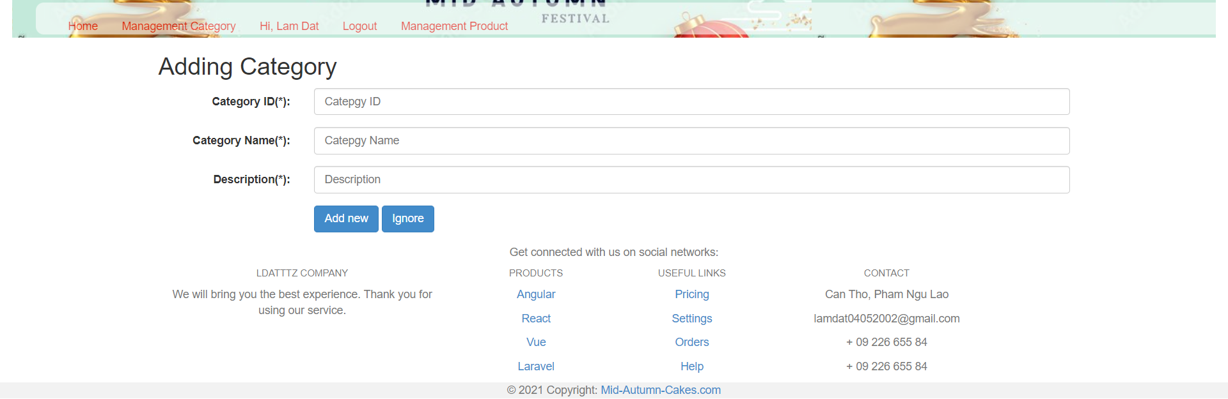

The administrator enters all the information in the blank boxes below and presses the Add New button.

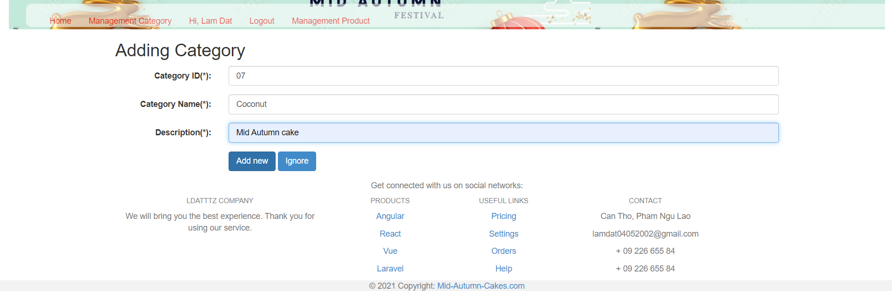

After clicking the Add New button, the new category will be added to the category list.

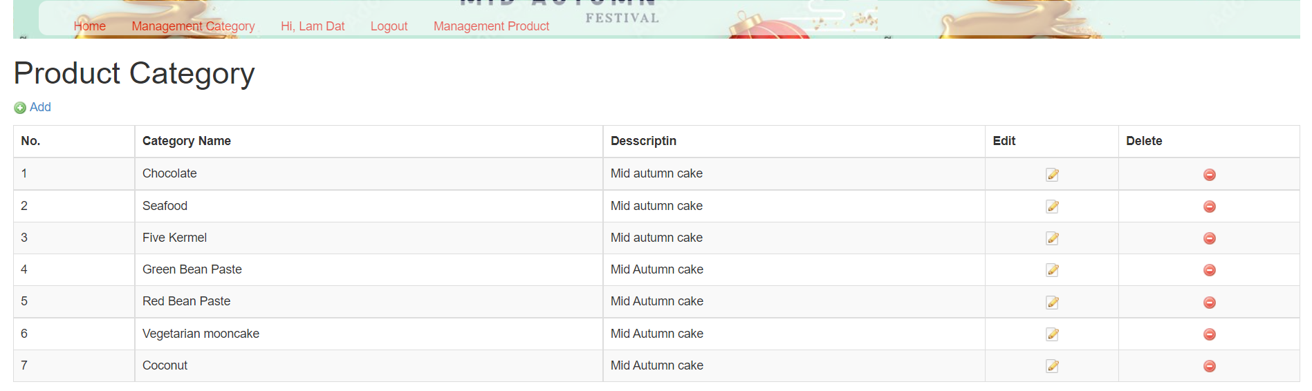

* Update Category

To update category information, the administrator must click on the Edit icon:

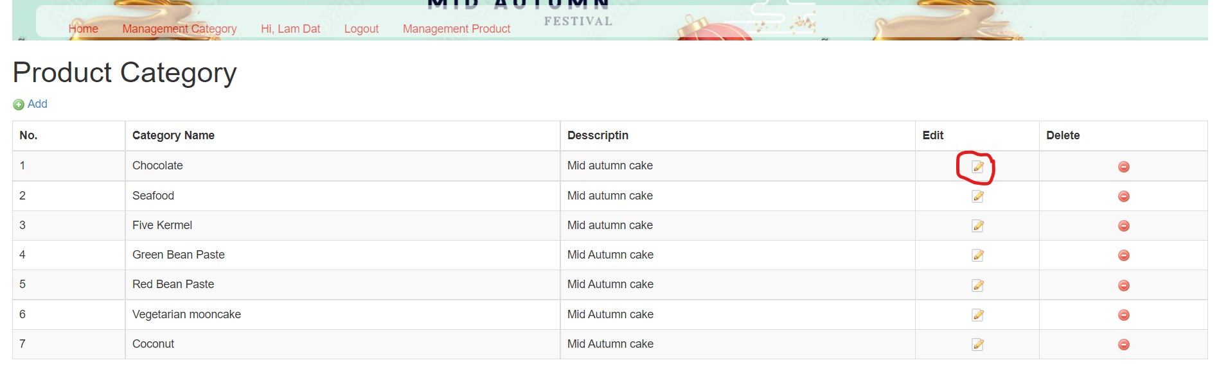

The following interface will be displayed.

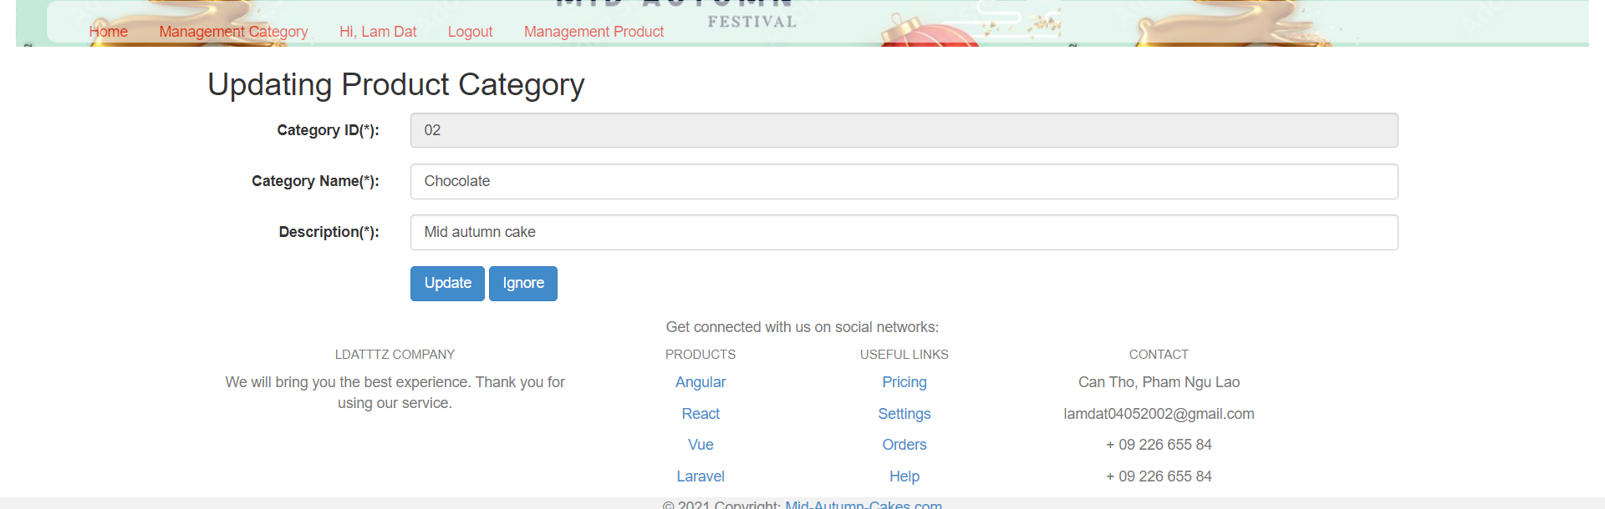

The administrator selects the blank cells you want to update, changes the information below and clicks the Update button.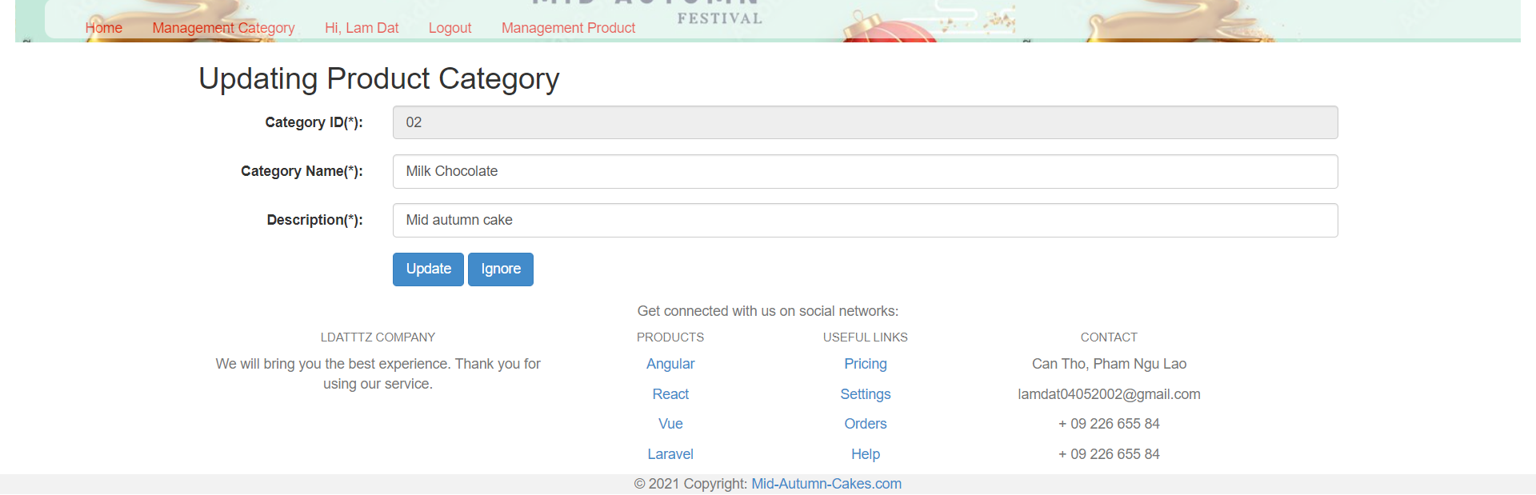

After clicking update, the information will be updated to the category list.

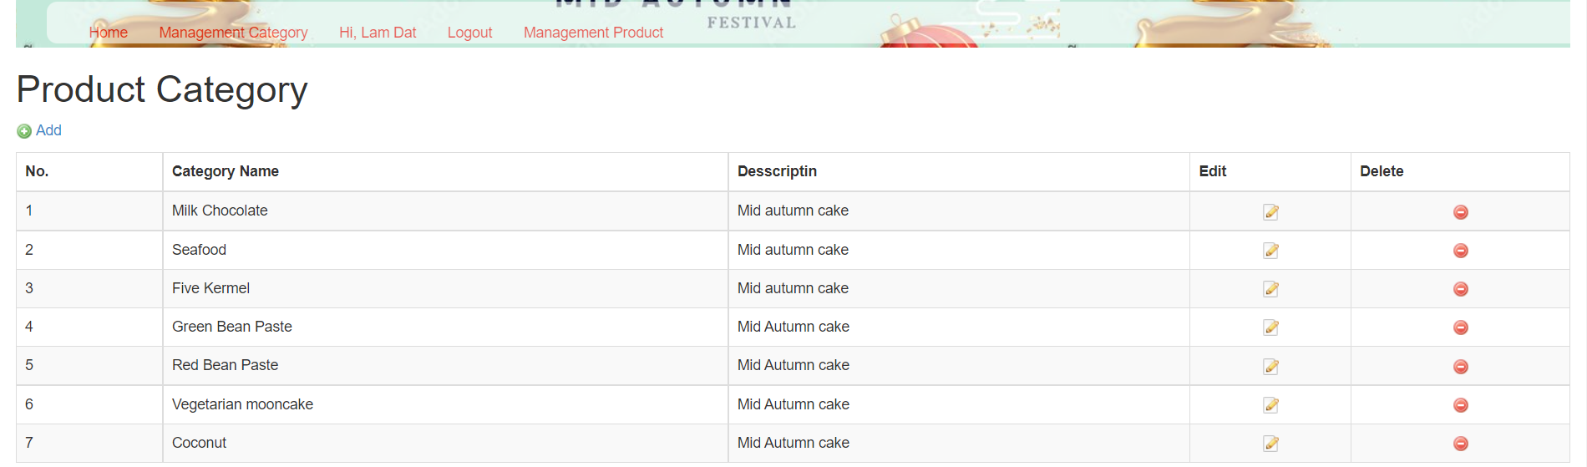

* Delete Category

To delete category information, an administrator selects the category they want to delete and clicks the delete icon: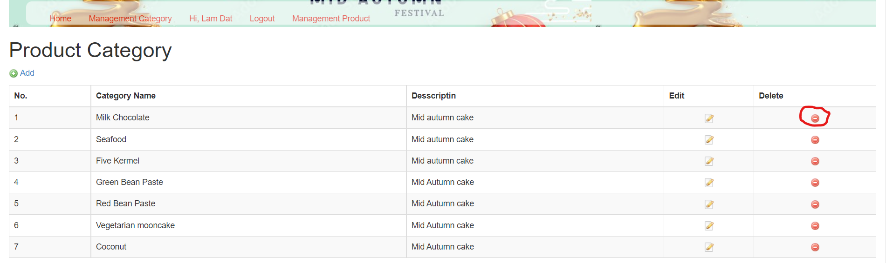

After clicking the delete icon, the following interface will be displayed to know for sure if you want to delete this category.

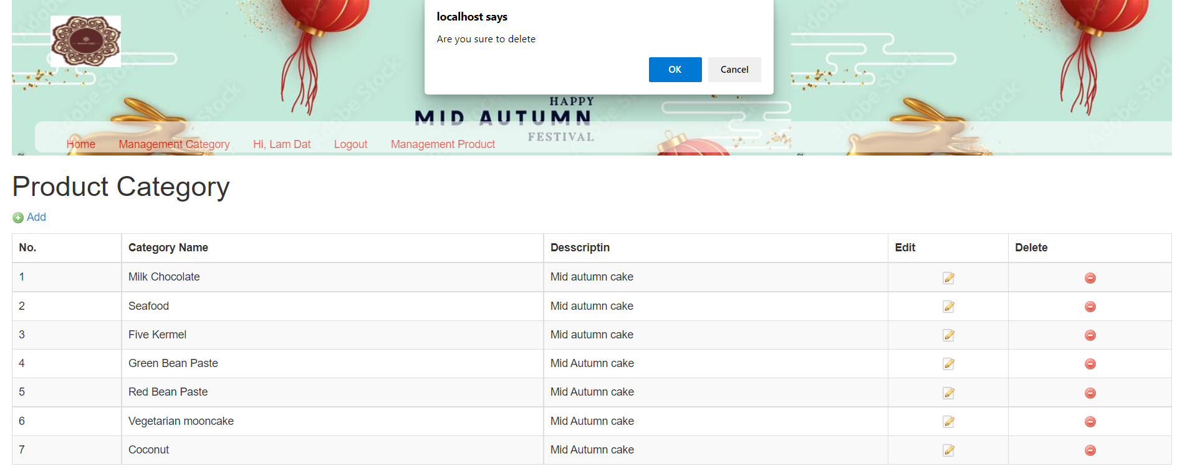

After clicking OK, the selected administrator category will be removed from the category list.

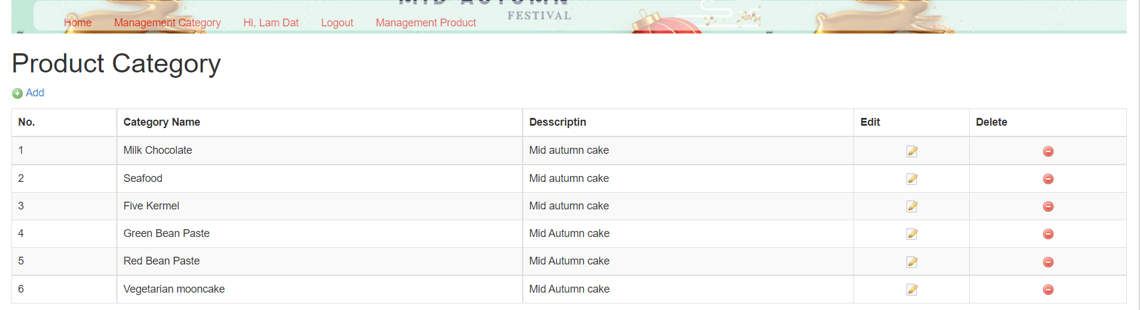

* **Product Management:**

This is a function that only administrators can access. If you are a user, an error message will appear.



* Add Product

To add product information, the administrator must click on the Add New icon:

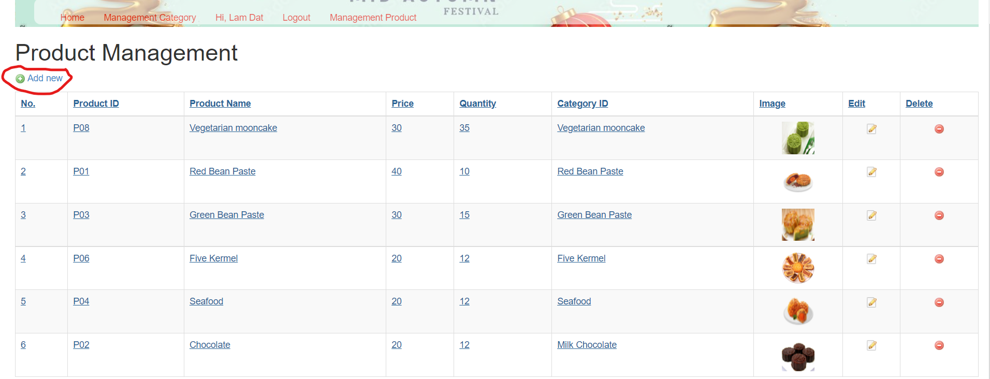

The following interface will be displayed.

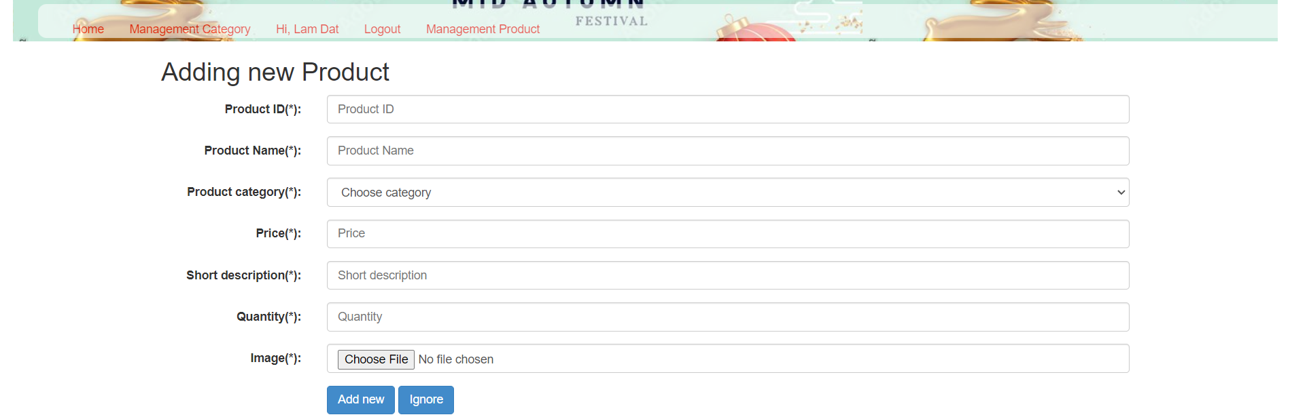

The administrator enters all the information in the blank boxes below and presses the Add New button.

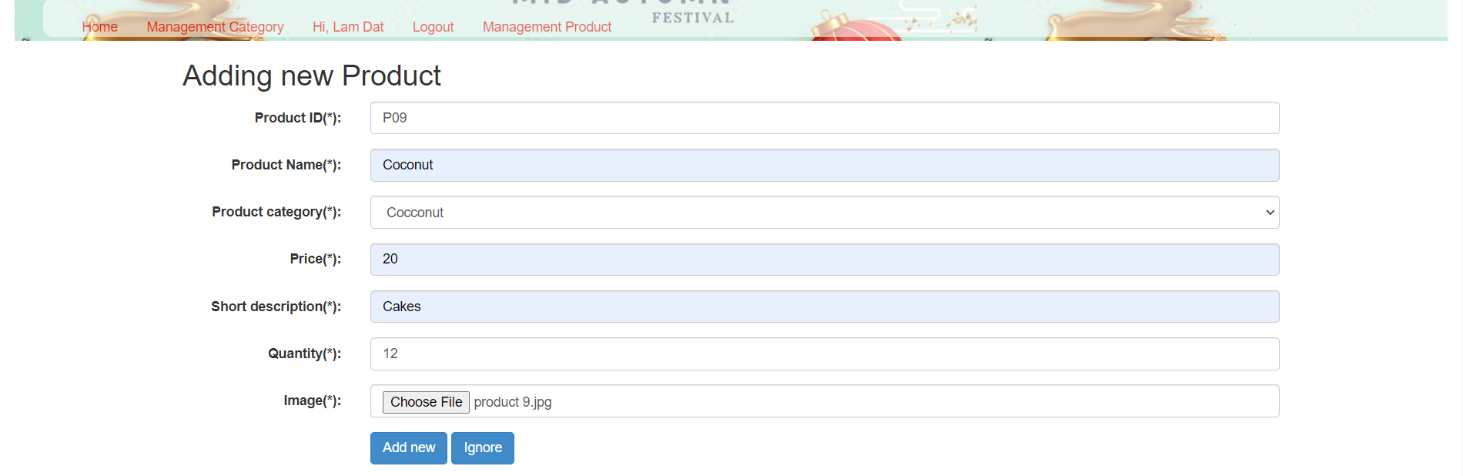

After clicking the Add New button, the new product will be added to the product list.

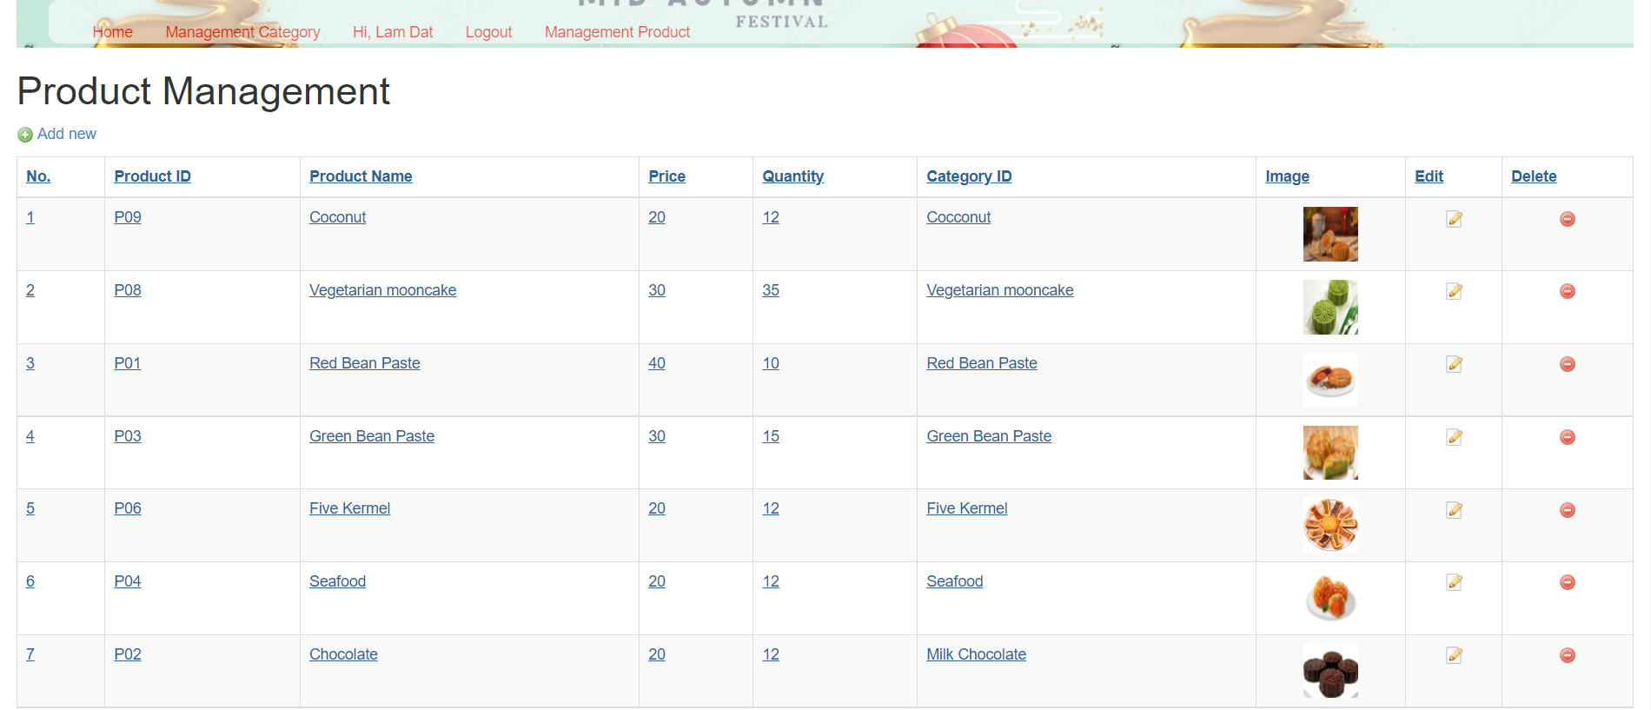

* Update Product

To update product information, the administrator must click on the Edit icon:

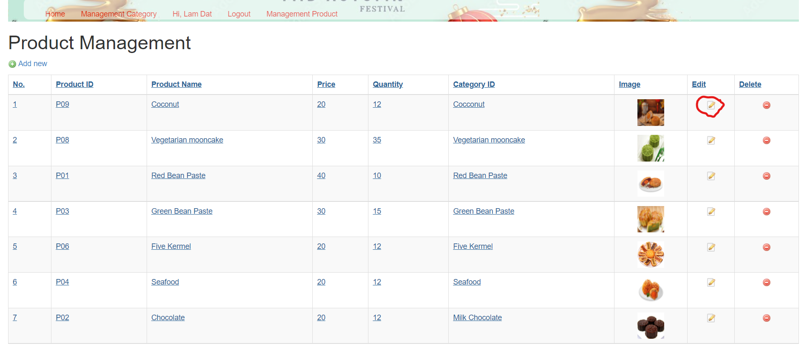

The following interface will be displayed.

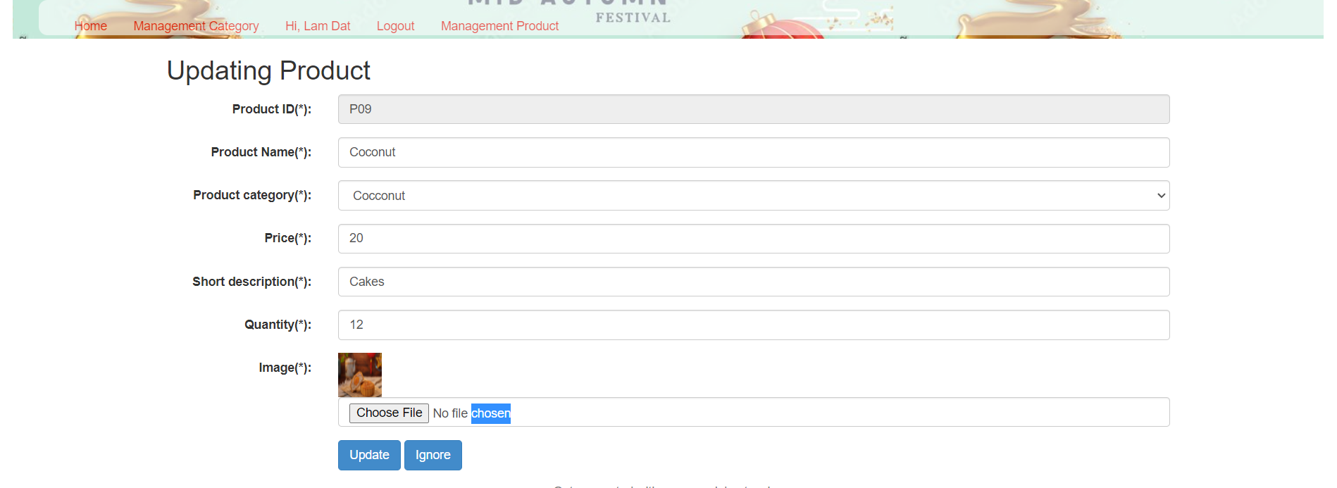

The administrator selects the blank cells you want to update, changes the information below and clicks the Update button.

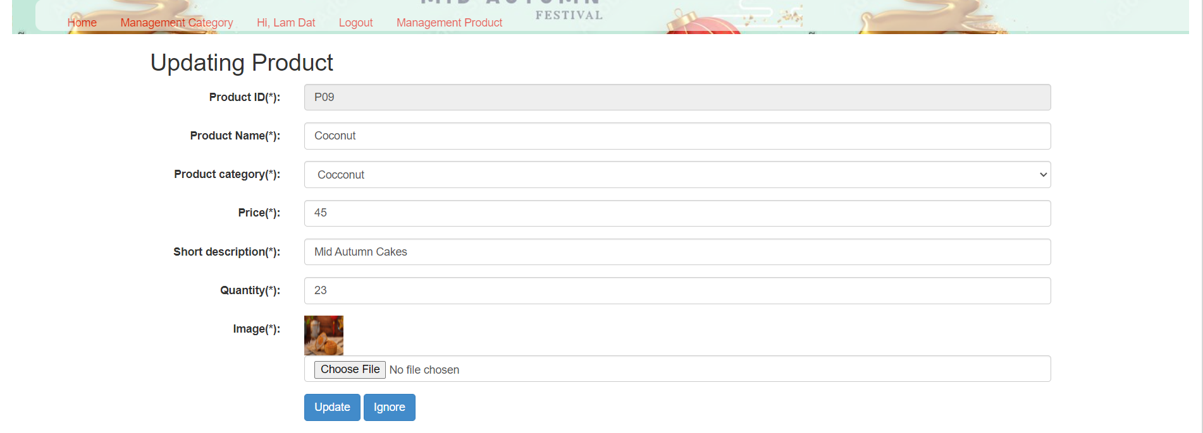

After clicking update, the information will be updated to the product list.

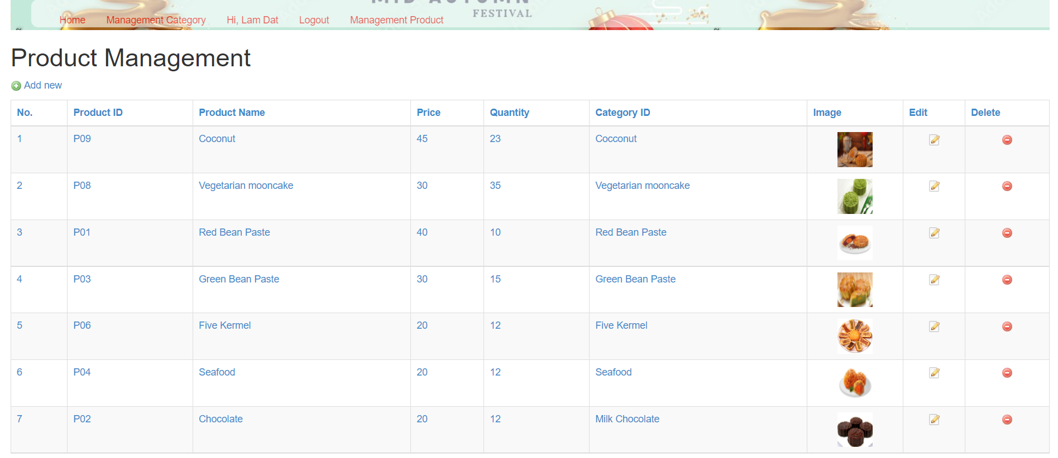

* Delete Product

To delete product information, an administrator selects the product they want to delete and clicks the delete icon:

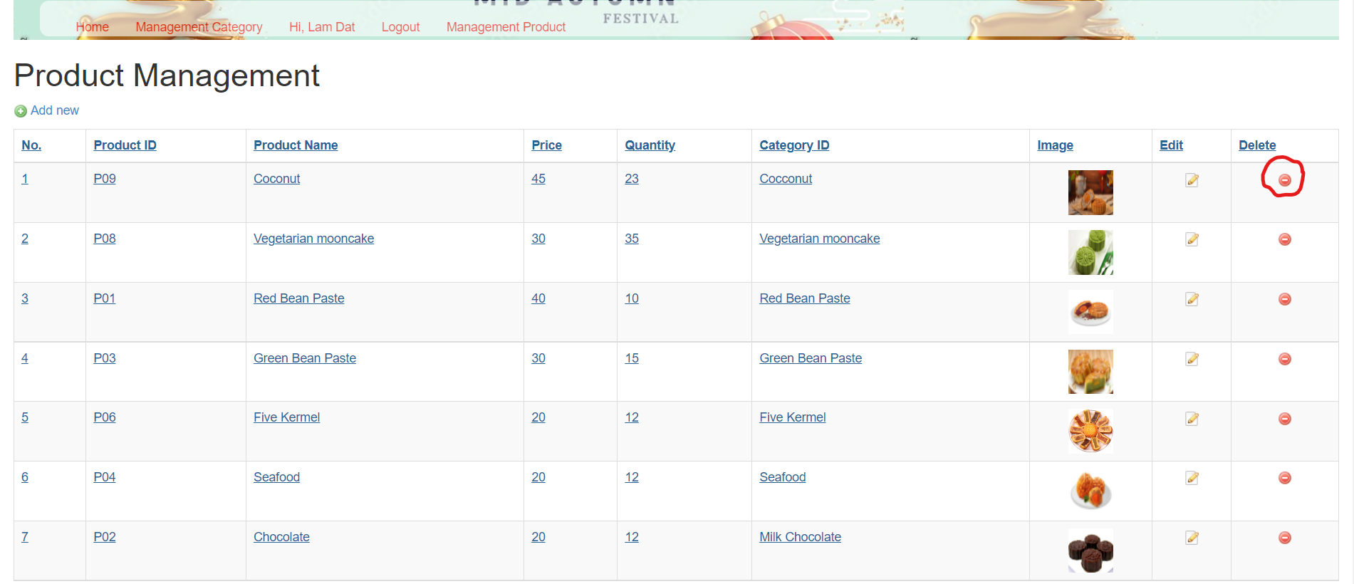

After clicking the delete icon, the following interface will be displayed to know for sure if you want to delete this product.

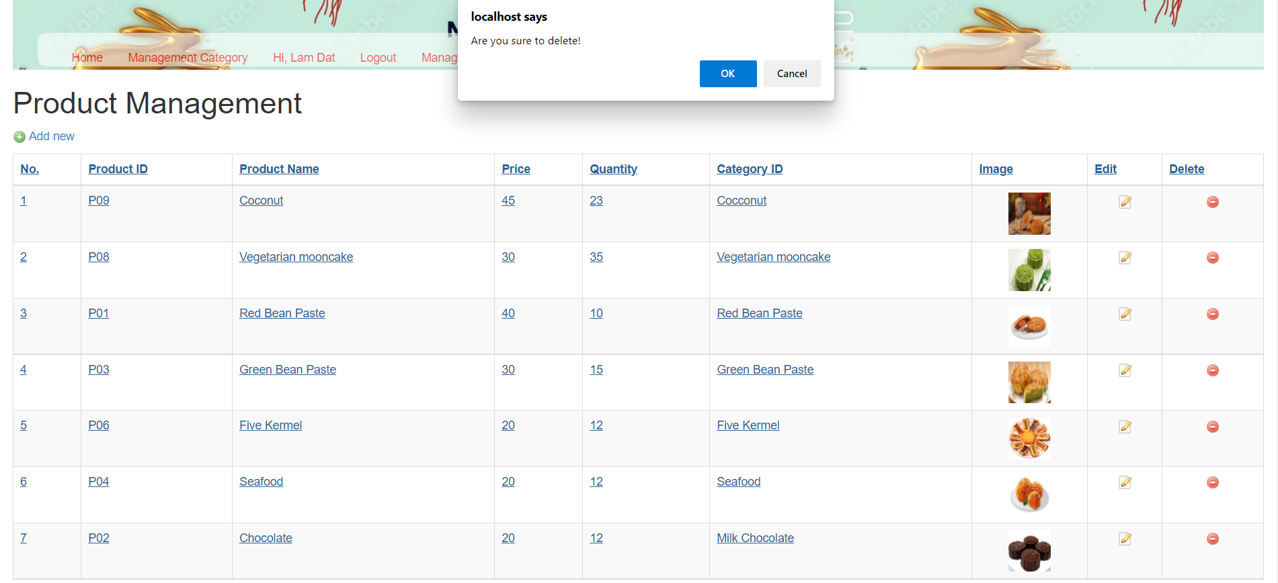

After clicking OK, the selected administrator product will be removed from the product list.

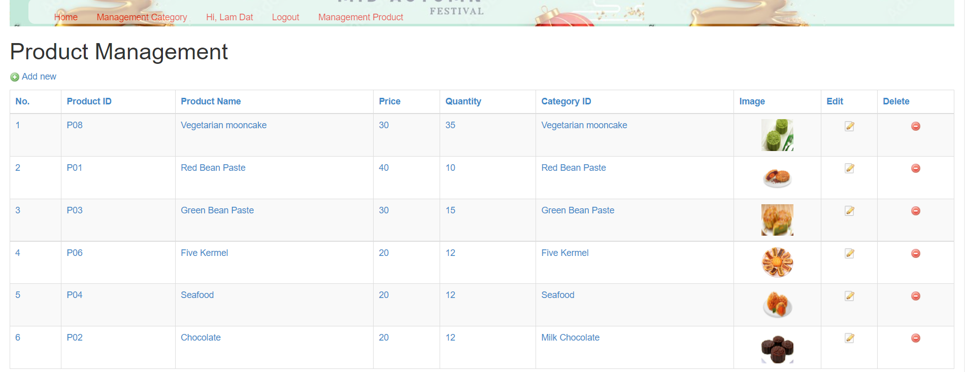

1. Chapter 4: Testing

**Test plan**

|  |  |  |  |  |  |  |
| --- | --- | --- | --- | --- | --- | --- |
| No | Test case | Function | Testing data | Expected output | Actual output | Evaluation |
| 1 | Verify that when the user enters valid information the message “You have registered successfully” will be displayed. | Register | Username: Lam Dat  Password:123456  Confirm Password:123456  Fullname: Tran Lam Dat  Email: lamdat@gmail.com  Address: Can Tho  Telephone: 0922665586  Gender: Male  Date of Birth: 4-5-2002 | The message is displayed "You have registered successfully ". | The message is displayed "You have registered successfully ". | Pass |
| 2 | Verify that the message "Username or email already exists" is displayed when the user enters the duplicate information. | Register | Username: Lam Dat  Password:123456  Confirm Password:123456  Fullname: Tran Lam Dat  Email: lamdat@gmail.com  Address: Can Tho  Telephone: 0922665586  Gender: Male  Date of Birth: 4-5-2002 | The message is displayed " Username or email already exists ". | The message is displayed " Username or email already exists ". | Pass |
| 3 | Verify that when the user enters a valid username and password, the home page will be displayed "Hi, (customer)" | Login | Username: Lam Dat  Password: 123456 | The home page is displayed "Hi, (customer)" | The home page is displayed "Hi, (customer)" | Pass |
| 4 | Verify that when the user enters an invalid username and password, the following message is displayed "you are logged in fail". | Login | Username: Tung Nguyen  Password: 123456 | The home page is displayed " you are logged in fail " | The home page is displayed " you are logged in fail " | Pass |
| 5 | Verify that new category will be added successfully when user enters valid information. | Add Category | Category ID: 03  Category Name: Coconut  Description: Mid Autumn Cakes | New category will be added to category list. | New category will be added to category list. | Pass |
| 6 | Verify that the message will be displayed "Duplicate category ID or Name " if that category is already available. | Add Category | Category ID: 03  Category Name: Coconut  Description: Mid Autumn Cakes | Home page is displayed "Duplicate category ID or Name " | Home page is displayed "Duplicate category ID or Name " | Pass |
| 7 | Verify that when administrator enters valid information, the product category will be updated successfully. | Update Category | Category ID: 03  Category Name: Milk Coconut  Description: Mid Autumn Cakes | This category will be updated to category list. | This category will be updated to category list. | Pass |
| 8 | Verify that if the administrator does not enter the Category Name, a message will be displayed "Enter Category Name, please". | Update Category | Category ID: 03  Category Name:  Description: Mid Autumn Cakes | This category will not be updated to the category list. | This category will not be updated to the category list. | Pass |
| 9 | Verify that when administrator clicks on delete icon. Home page will be displayed “Are you sure to delete?”. | Delete Category | The administrator clicks on delete icon. | Home page is displayed “Are you sure to delete?”. | Home page is displayed “Are you sure to delete?”. | Pass |
| 10 | Verify that new product will be added successfully when user enters valid information. | Add Product | Product ID: P09  Product Name: Coconut  Product category: Coconut  Price: 20  Short description: Cakes  Quantity: 12  Image: product 9.jbg | New category will be added to category list. | New category will be added to category list. | Pass |
| 11 | Verify that the message will be displayed "Duplicate product ID or Name " if that product is already available. | Add Product | Product ID: P09  Product Name: Coconut  Product category: Coconut  Price: 20  Short description: Cakes  Quantity: 12  Image: product 9.jbg | Home page is displayed "Duplicate product ID or Name " | Home page is displayed "Duplicate product ID or Name " | Pass |
| 12 | Verify that when administrator enters valid information, the product will be updated successfully. | Update Product | Product ID: P08  Product Name: Vegetarian mooncake  Product category: Vegetarian mooncake  Price: 30  Short description: Cakes  Quantity: 35  Image: product 6.jbg | This product will be updated to product list. | This product will be updated to product list. | Pass |
| 13 | Verify that if the admin does not enter a number for the price line, a message will be displayed "Product price must be number". | Update Product | Product ID: P08  Product Name: Vegetarian mooncake  Product category: Vegetarian mooncake  Price: abc  Short description: Cakes  Quantity: 35  Image: product 6.jbg | Home page is displayed “Product price must be number?”. | Home page is displayed “Product price must be number?”. | Pass |
| 14 | Verify that when administrator clicks on delete icon. Home page will be displayed “Are you sure to delete?”. | Delete Product | The administrator clicks on delete icon. | Home page is displayed “Are you sure to delete?”. | Home page is displayed “Are you sure to delete?”. | Pass |